Final Review

Name: _____________________________________________________________________________________
ID number: ___________________ Group: ____________ Date: ___________________
Evaluation of Functions
Evaluate the indicated function.
$f\left(x\right)=5x+1$ $g\left(x\right)=x^{2}-9$ $h\left(x\right)={\left(x+2\right)}^{3}$ $k\left(x\right)=\sqrt{x+2}-1$
$$h(-3)$$ | $$f\left(\frac{1}{5}\right)$$ |  | $$g(4)$$
$$k\left(2\right)$$ | $$h\left(5t\right)$$ |  | $$g\left(e+4\right)$$
$$f({\left(x-1\right)}^{2})$$ |  | $$k(t^{2}+t-1)$$
Operations with functions
1. Combine the functions according to the indicated operation.
$f\left(x\right)=x^{2}+1$ $g\left(x\right)=x-4$
- Operation 1: $\left(f+g\right)\left(x\right)$

- Operation 2: $(f-g)(3)$

- Operation 3: $(f*g)(-4)$

- Operation 4: $\left(\frac{f}{g}\right)(0)$ and state its domain.

2. Combine the functions that model a real-life situation.
a. Trey and his wife are each starting a saving plan. Trey will initially set aside $250 and, then, add $145 every month to the savings. The amount A (in dollars) saved this way is given by the function $A=250+145N$, where N is the number of months he has been saving.
His wife will not set an initial amount aside but will add $485 to the savings every month. The amount B (in dollars) saved using this plan is given by the function $B=485N$.
Let T be the total amount (in dollars) saved using both plans combined. Write an equation relating T to N. Simplify your answer as much as possible.

b. A small publishing company is releasing a new book. The production costs will include a one-time fixed cost for editing and an additional cost for each book printed. The total production cost C (in dollars) is given by the function $C=650+15.95N$, where N is the number of books.
The total revenue earned (in dollars) from selling the books is given by the function $R=32.80N$.
Let P be the profit made (in dollars). Write an equation relating P to N. Simplify your answer as much as possible.

Composition of functions
1. For each of the following pair of functions, find the indicated composition.

Functions:
$f\left(x\right)=x^{2}+7$ $g\left(x\right)=\sqrt{x+5}$

- $\left(f∘g\right)(x)$ and its domain

- $\left(g∘f\right)\left(-\frac{2}{7}\right)$

Functions:
$f\left(x\right)=\frac{7x}{x+2}$ $g\left(x\right)=\frac{5}{x}$

- $\left(f∘g\right)(x)$ and its domain

- $\left(f∘f\right)(x)$

- $(g∘g)(x)$

Functions:
$f\left(x\right)=\sqrt[3]{2-x}$ $g\left(x\right)=2x^{3}-3$

- $(g∘g)(x)$

- $\left(g∘f\right)\left(10\right)$

2. Based on the given graphs of functions $f(x)$ and $g(x)$, evaluate the following.

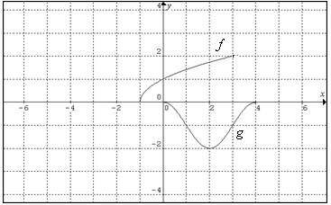

1. $\left(g∘f\right)\left(3\right)$ | 3. $(f∘g)(4)$ | 5. $(g∘f)(0)$
2. $\left(f∘f\right)(-1)$ | 4. $(g∘g)(1)$ | 6. $(f∘g)(2)$

Inverse Function
1. Determine algebraically whether the two given functions are the inverse of each other or not. Justify your answer with $f(g(x))$ , and $g(f(x))$.

$f\left(x\right)=1+x^{3}$ $g\left(x\right)=\sqrt[3]{1+x}$

2. Graph the given function and state its domain and range. Then, graph its inverse and state its domain and range. Finally, graph the reflection line.
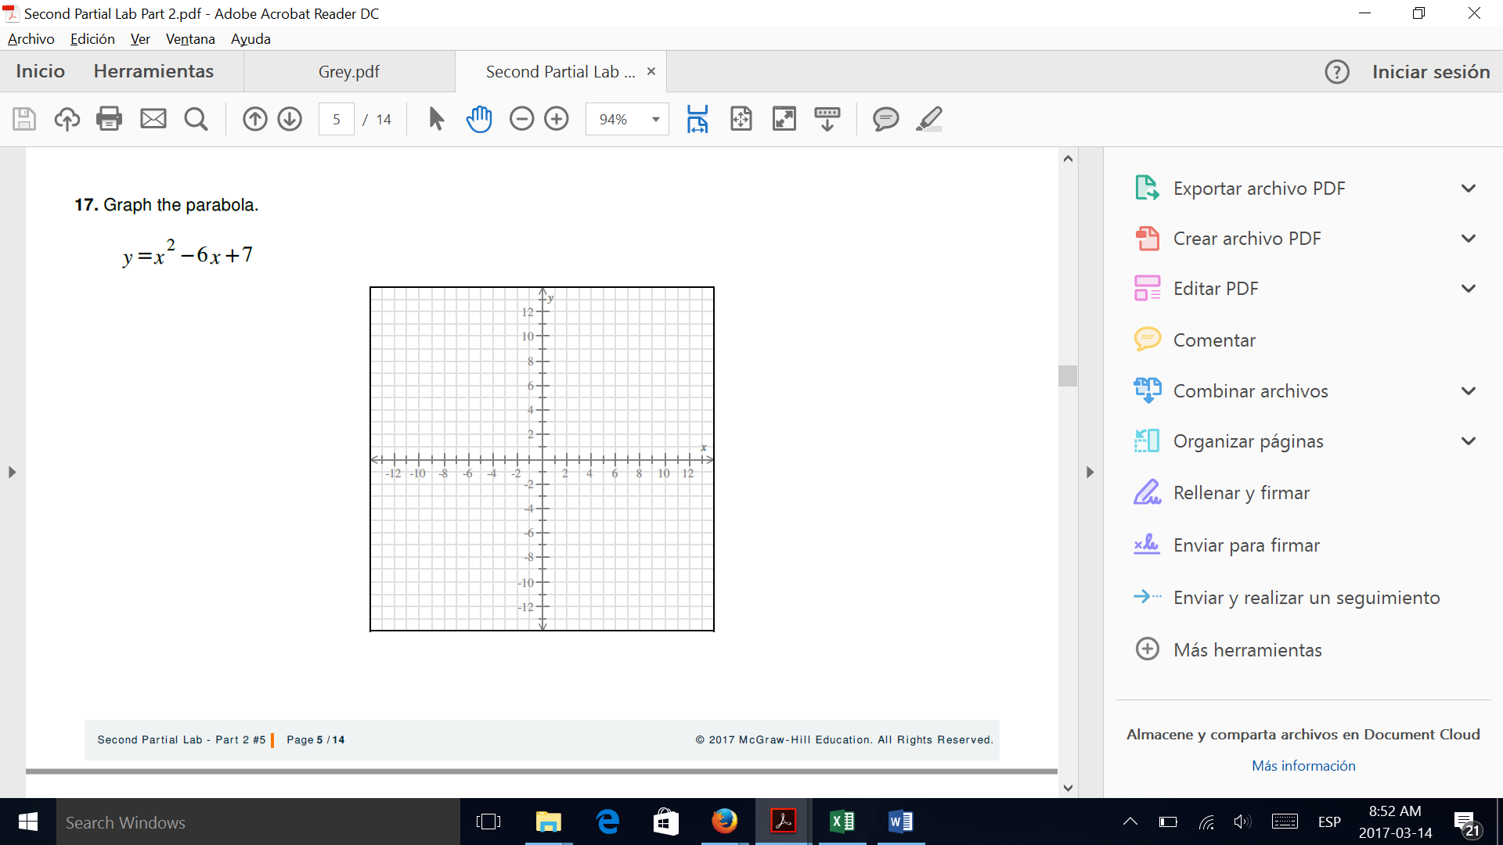
a. $f\left(x\right)=\sqrt{5-2x}$

domain: ____________________
range: __________________

Inverse function: ______________________
Domain of $f^{-1}\left(x\right)$: ___________________________
Range of $f^{-1}\left(x\right)$: ____________________________

b. $h\left(x\right)=\frac{x+6}{5+3x}$

domain: _________________________
range: ___________________________

Inverse function: ______________________
Domain of $f^{-1}\left(x\right)$: __________________________
Range of $f^{-1}\left(x\right)$: ____________________________

Rational Functions
1. Given the following functions find the vertical and horizontal asymptotes, the empty point (hole), and the x and y intercepts. Then, graph the function and state its domain and range.

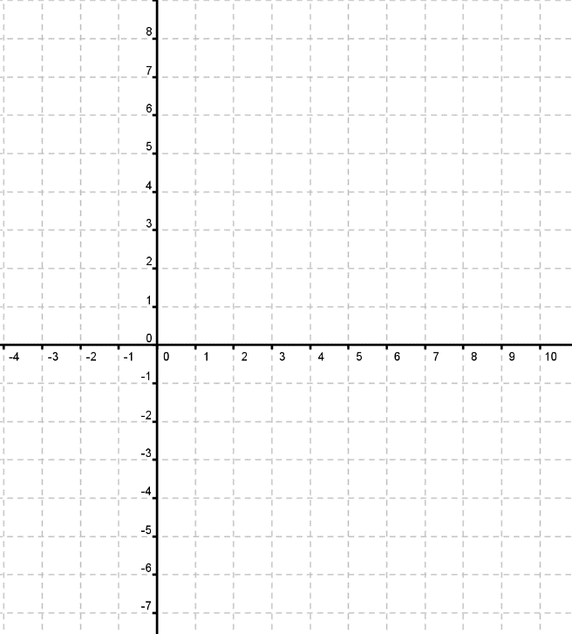
a) $y=\frac{2x-4}{2x^{2}+x-10}$

VA:____________
HA: ____________
“Y” intercept: _____________
“X” intercept: _______________
Hole:__________
Domain: _________ Range: _____________

Piecewise Functions
1. Graph the following piecewise functions, determine the domain and range.
a. $f\left(x\right)=\left\{\begin{aligned}\left|x+2\right|+1; x<-2 \\ -x^{2}+4; -2≤x≤2 \\ \sqrt{x-2}; x>2\end{aligned}\right.$



b. $f\left(x\right)=\left\{\begin{aligned}\frac{1}{x}; x<0 \\ x; x≥0\end{aligned}\right.$


3. Determine the piecewise function that corresponds to the situation and sketch its graph.

A monthly subscription for a gym cost is $380 if the package is for 6 months or less. If you buy a subscription for more than 7 months up to 12 months, the monthly cost reduces to $300, and if you buy a subscription for any period longer than a year, the monthly cost further reduces to $250.

Remember to sketch its graph.

Exponential Functions
Given the following functions find the asymptote, and the critical point. Then, graph the function and state its domain and range.
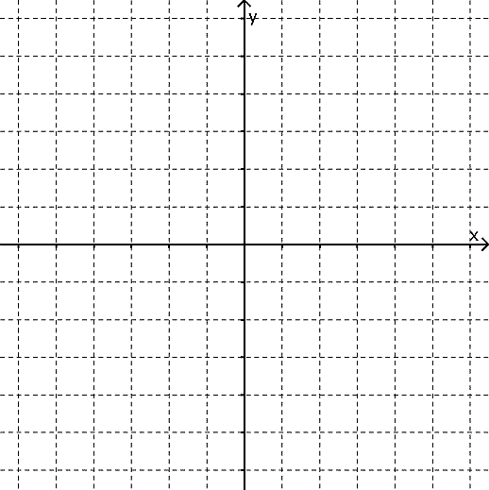
a) $y={\frac{1}{2}}^{-x}+2$
Asymptote: ____________
Critical point: _____________
Domain: ____________________
Range: _____________________


b) $y=-4^{x-3}+1$

Asymptote: ____________
Critical point: _____________
Domain: ____________________
Range: _____________________

c) $y=e^{-x+1}+1$

Asymptote: ____________
Critical point: _____________
Domain: ____________________
Range: _____________________

Logarithmic Functions

Given the following functions find the asymptote, and the critical point. Then, graph the function and state its domain and range.
a) $\text{y }=-\log_{2}\left(x-3\right)+5$
Asymptote: ____________
Critical point: _____________
Domain: ____________________
Range: _____________________


b) $\text{y =Ln }\left(-x+2\right)+1$

Asymptote: ____________
Critical point: _____________
Domain: ____________________
Range: _____________________


c) $y=2+\log_{\frac{1}{2}}{(x+3)}$

Asymptote: ____________
Critical point: _____________
Domain: ____________________
Range: _____________________

Properties of Logarithms
1. Use the properties of logarithms to condense the following logarithmic expression. To show the use of each property, write each step of the process.
$$\frac{1}{5}\left[\log_{8}\left(y\right)+2\log_{8}\left(y+4\right)\right]-\log_{8}\left(y-1\right)+\log_{8}\left(\sqrt[3]{y}\right)$$

2. Use the properties of logarithms to expand the following logarithmic expression. To show the use of each property, write each step of the process.
$$\log{\sqrt[3]{\frac{5{\left(x^{2}y\right)}^{7}}{2\sqrt{z^{11}}}}}=$$

3. Find the value of each expression. If the exercise requires it, use the change of base formula, writing its whole procedure.

$$\log_{4}{20}$$ | $$\log_{3}{81}$$ | $$\log{4}$$ | $$\ln{232}$$
$$\log{10}$$ | $$\ln{e}$$ | $$\log_{x}{y}$$ | $$\log_{81}{9}$$

Exponential and Logarithmic Equations
Solve the following equations.
a) $\log_{2}{(2x+2)}-\log_{2}\left(x+1\right)=3$

b) $2\log_{3}{x}-\log_{3}\left(x-4\right)=2+\log_{3}{2}$

c) $\ln{2x}+\ln{4}=5$

d) $\log{(3-x)}-\log\left(x+9\right)=0$

e) $\log_{16}{x}+\log_{16}{(x-4)}=\frac{5}{4}$

f) $\ln{x}+\ln{(x+1)}=1$

g) $\ln\left(x+1\right)-\ln\left(x-2\right)=\ln{x}$

h) $\ln{30}*4^{x+1}=10$

i) $-7+\frac{1}{3}\log_{2}\left(x-6\right)=-6$

j) $\log{(x+4)}-\log{x}=\log{(x+2)}$

k) $\log\left(x-6\right)=\log\left(2x+1\right)$

l) $5^{x-2}=\frac{1}{25}$

m) $e^{x^{2}+6}=e^{x}$

n) $25\left(e^{x-1}\right)=100$

o) $3^{4-x}=8^{2x-2}$

p) $3^{x+3}+3^{x}=81$

q) $12+2\left(7^{x-1}\right)=62$

r) $2\left(e^{2x}\right)-\left(e^{x}\right)-21=0$

Modeling Exponential and Logarithmic Functions
1. A total of $ 3,000 is invested at an annual interest of 5.4 %.
a) Write the model (function) of this situation.

b) Find the balance after 3 years if it is compounded:
annually | monthly | daily | continuously

c) If the interest is compounded continuously, how long will it triple your money?

2. The population of a certain city is given by $P\left(t\right)=234e^{0.071t}$, where P is measured in thousands of people and t is measured in years from the year 2000.

a) Find the population for the 2014. | b) Find the population for the year 2027. | c) Find when the population will be 3 million.
3. The initial frog population in a small pond is 75 frogs, and the annual growth rate is 18% .
a) Write the model (function) of the population “p” after “t” years.

b) Calculate the expected population after 3 years.

c) Calculate the number of years needed for the frog population to be 540.

4. A sample of a radioactive substance has an initial mass of 763.3 mg. This substance follows a continuous exponential decay model and has a half-life of 5 days.
a) Which is the decay rate (as percentage to the tenth)?

b) How much will be present in 22 days?

c) How much time will it take to reach 600 mg?

6. The magnitude of an earthquake on the Richter scale is calculated from the equation
$R=log\left(\frac{I}{I_{0}}\right)$, where I₀ is the smallest earthquake that can be recorded with a seismograph.
Based in this information, how many times more intense is an earthquake of 8.6 on the Richter scale with respect to an earthquake of 5.4 on the Richter scale?

7. In the chemistry world, pH is used to describe the acidity and basicity of a substance through the equation $pH=-log\left(H\right)$, H being the concentration of hydrogen ions in moles per liter.

Jeffrey knows that avocados have pH of 6.5, and chocolate has a pH of 5.4. Based on this information, which of these two has a lower concentration of hydrogen ions?

8. James and his friends want to go to a jet hangar, and he’s worried about hearing loss. He knows that the exposure to sounds above 120db can be a cause for hearing loss, he also knows that a jet take off has an intensity of $I=2.5 x {10}^{13}I_{0}.$
Considering the formula $β=10log\left(\frac{I}{I_{0}}\right)$, where I₀ is the finest detectable sound by a human ear, should James and his friends wear ear protection at the hangar?

Conic Sections
1. Graph the conic section and state which kind of conic section it is.
a) $\frac{{\left(x-1\right)}^{2}}{16}+\frac{{\left(y-2\right)}^{2}}{81}=1$

b) ${\left(x-2\right)}^{2}+{\left(y+3\right)}^{2}=9$

c) $x^{2}+{(y-2)}^{2}=36$

d) $y^{2}=-12(x-5)$

e) $\frac{{\left(x-2\right)}^{2}}{25}+\frac{{\left(y+1\right)}^{2}}{9}=1$

f) ${x=-8\left(y-5\right)}^{2}-1$

g) $\frac{x^{2}}{16}-\frac{y^{2}}{9}=1$

h) $\frac{{\left(y-4\right)}^{2}}{25}-\frac{{\left(x+5\right)}^{2}}{4}=1$

2. Find the standard form of the conic section represented by each of the following equations and state which kind of conic section it is.
a) $4x^{2}+9y^{2}-8x+18y=-12$

b) $16x^{2}-9y^{2}-96x-54y-81=0$

c) $5x^{2}+5y^{2}-60x-20y+40=0$

d) $3x^{2}+3y^{2}-36x+72=0$

e) $x^{2}+y^{2}-8x+2y+1=0$

f) $-16x^{2}+9y^{2}-128x+18y-391=0$

g) $x^{2}+2y^{2}-2x+12y+19=0$

h) $4y^{2}-4y-16x+17=0$

i) $9x^{2}+4y^{2}-18x+16y+61=0$

k) $2x^{2}+2y^{2}-12x-20y+34=0$

l) $75x^{2}+90x+25y+98=0$

4. Write the general form equation from the following graphs and state which kind of conic section it is.
a) 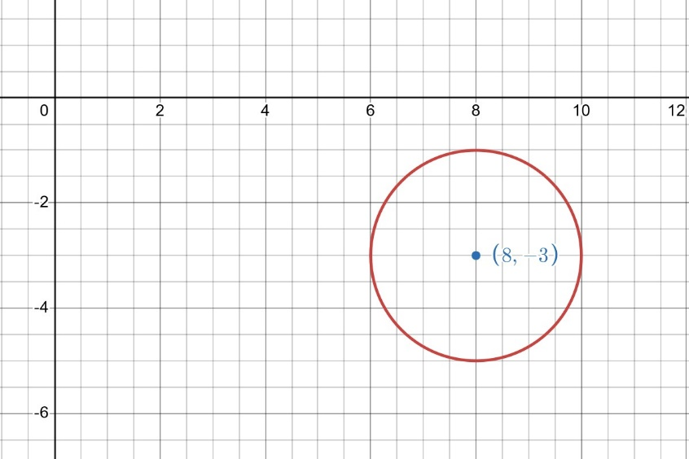

b) 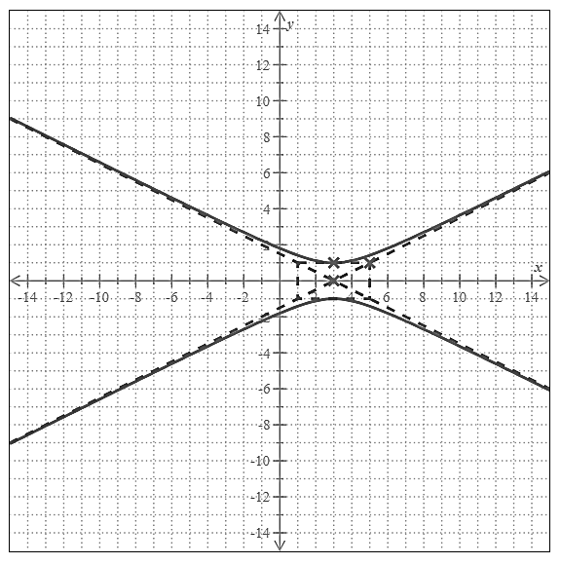
c) 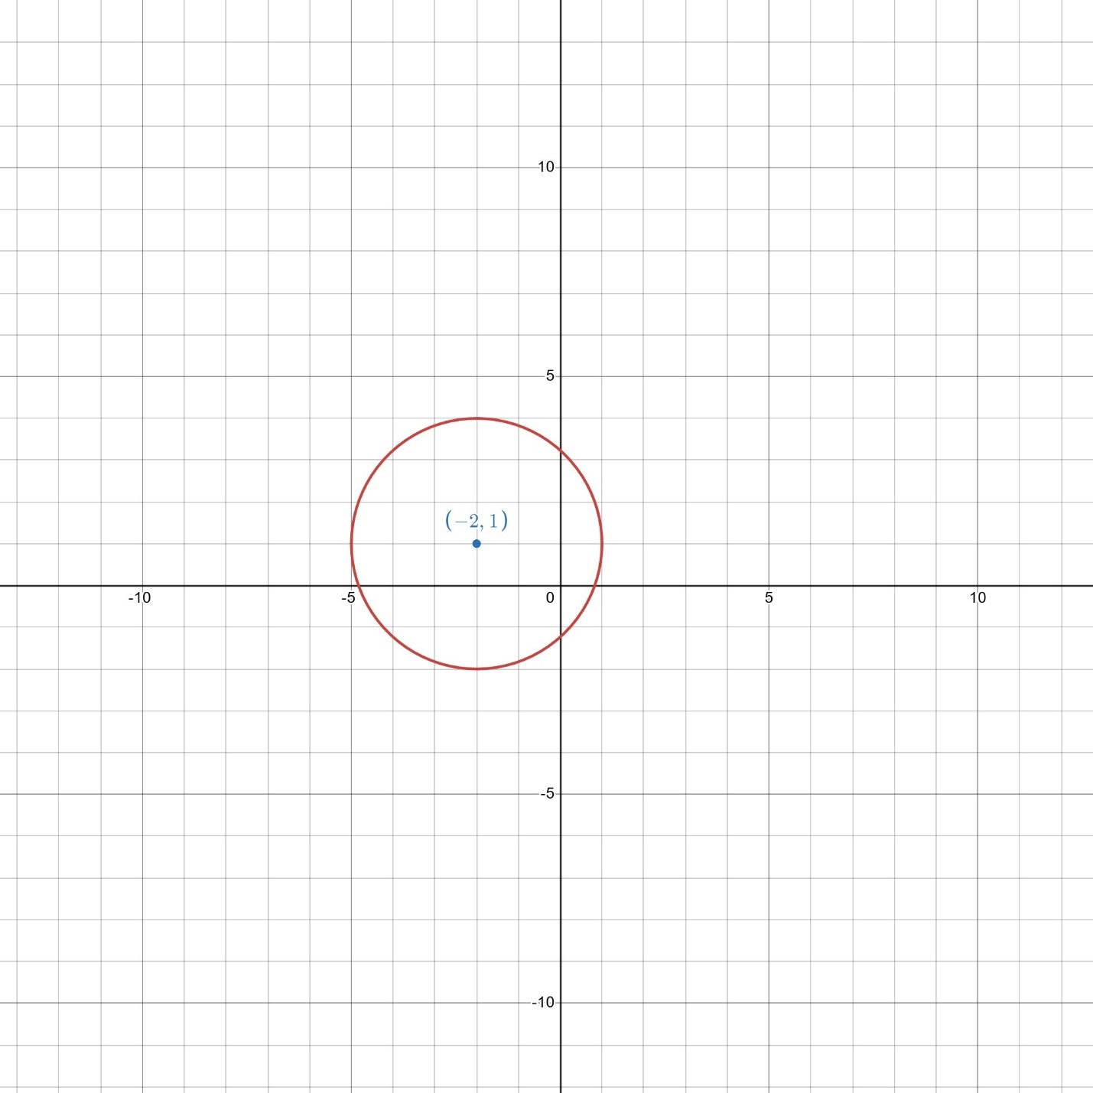

d) 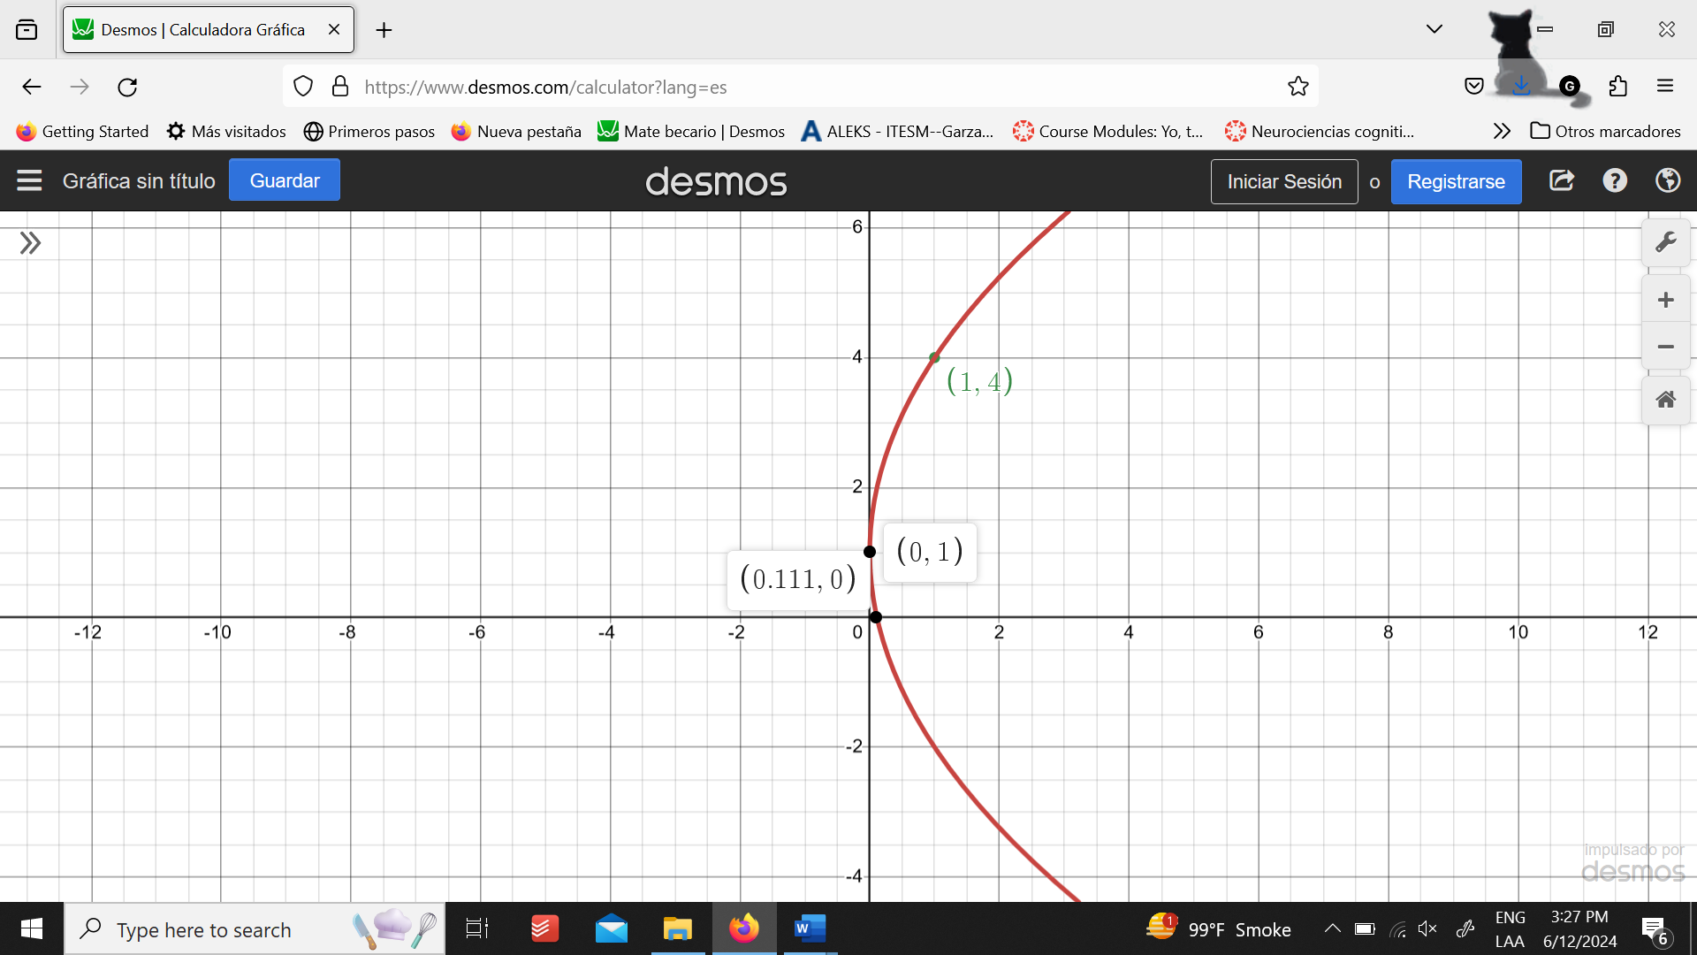

e) 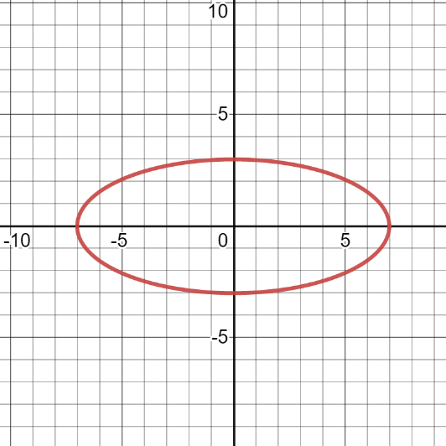

f) 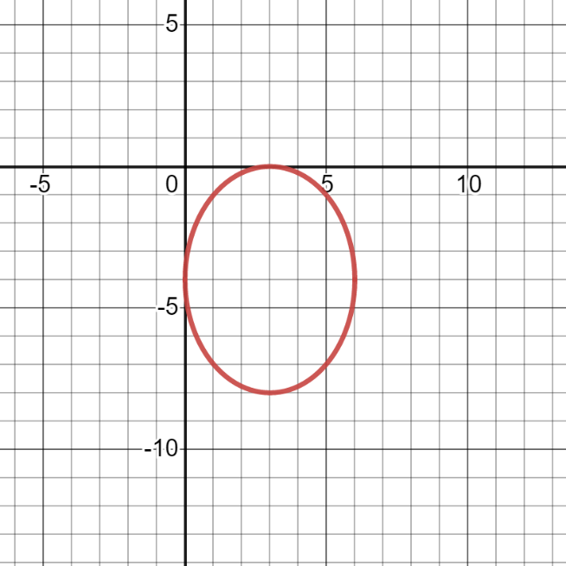

g) 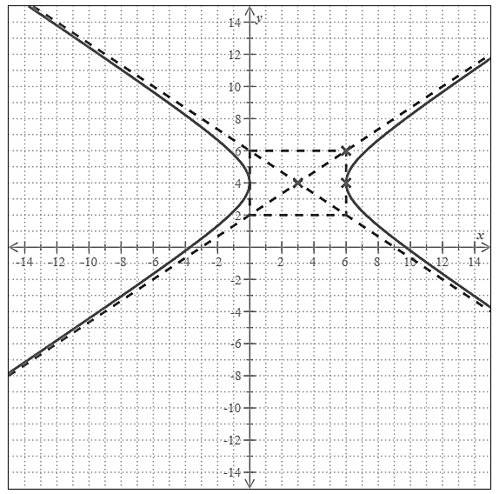

h) 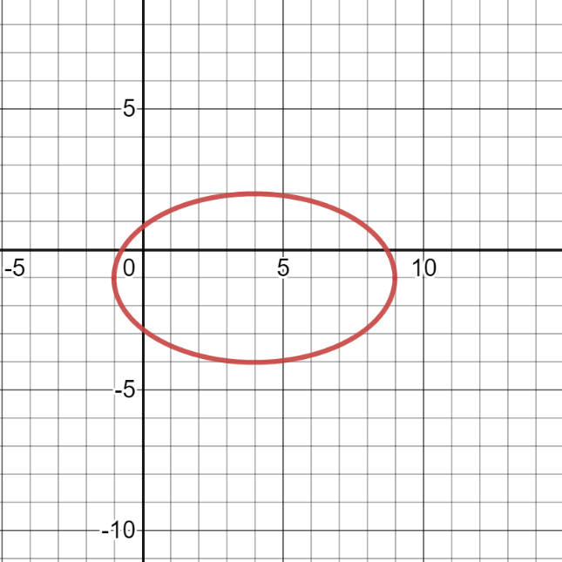

i) 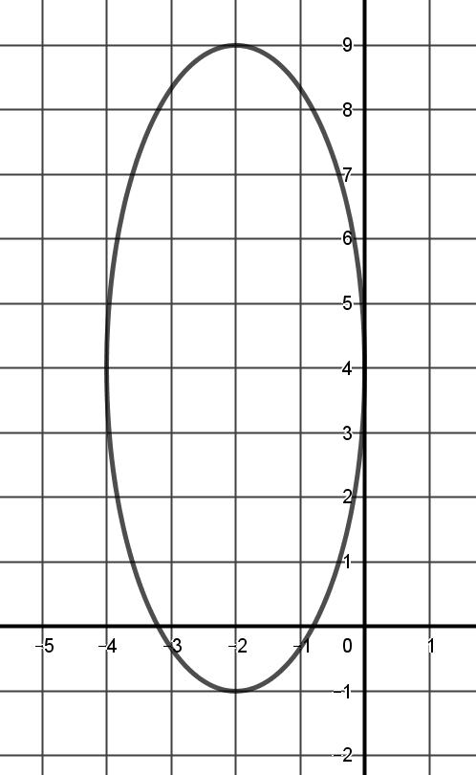

j) 